Using AI to Predict Lung Cancer Early by
Combining Clinical Records and Medical Imaging

Author 1: Jashandeep singh
AIT CSE,AI and ML
Chandigarh university
Chandigarh , Punjab
24BAI70540@cuchd.in

Author 4:Pushpit kumar gaur
AIT CSE ,AI and ML
Chandigarh university
Chandigarh , Punjab
24BAI70534@cuchd.in
Author 2: Poonam Jyoti
Assistant professor
AIT CSE,AI and ML
Chandigarh university
Chandigarh , Punjab
Poonam.e16441@cumail.in

Author 5:Kush
AIT CSE ,AI and ML
Chandigarh university
Chandigarh , Punjab
24BAI70604@cuchd.in
Author 3:Anshul
AIT CSE,AI and ML
Chandigarh university
Chandigarh , Punjab
24BAI70425@cuchd.in

Abstract— Lung cancer is a reason for death of a large amount of people who suffer from cancer all over the world. This is due to the fact that it is often found late. If we can find lung cancer in late stage it gets difficult to save lives. The problem is that it is difficult to tell if a growth in the lung is bad or not when we examine pictures from a CT scan. This is because, the difference between a growth and a harmless one can be very small.
Even though computers are good at looking at pictures of the body they usually only look at the pictures. Don't think about other important information that doctors are using to make a diagnosis. This research is about a way to use computers to help find lung cancer to find lung cancer early. We made a system which looks at pictures from CT scans and also thinks about information that doctors uses like how old the person is, if they smoke and if they have trouble breathing.
We used a kind of computer model to look into the pictures and then put what it was finding with the other information. This makes the computer better understand what is going on and make predictions. Our system is very good at finding lung cancer it gets it 98 or 99 percent of the time. It also has no misses in terms of lung cancer, or misses a diagnosis in someone who does not have lung cancer. We yesterday do think this system could be very helpful, to doctor and could help save lives by finding lung cancer. Lung cancer is a problem and we need to find better ways to detect it like our system.
Keywords— Artificial Intelligence (AI), Lung Cancer Detection, Early-Stage Prediction, Deep Learning, VGG16, Transfer Learning, Multimodal Learning, CT Imaging, Clinical Data Integration, Medical Image Analysis, Feature Fusion, Computer-Aided Diagnosis (CAD).

Introduction
In addition, Lung cancer a type of cancer which is one of the most hazardous and harmful to life diseases in the world which claims a big set of percentage of cancer deaths every year. In addition, in spite of the improvements in the medical technology, survival rate of the patients suffering from lung cancer is still low due to the fact that the disease is diagnosed very late. In addition, Early-stage lung cancer is very asymptomatic or may have some mild symptoms, which usually are ignored. As a result, patients are usually diagnosed with the disease when it is in an advanced stage, which has severe effects on the survival rate[5] , [25] . However, Computed Tomography (CT) scans have been well etched into the screening process for lung cancer because of the ability of the latter to spot minute pulmonary nodules [6]. In addition, the analysis of CT scans is prone to large variations and requires highly experienced radiologists.

Furthermore, The growing amount of medical image data in the medical institutions makes the manual screening of the medical images a time consuming activity[8],[4]. Artificial Intelligence (AI), specifically Deep Learning (DL), has come up with very good performance in the domain of medical image analysis. Convolutional Neural Networks (CNNs) are able to automatically learn hierarchical feature representations that do not require manual feature extraction
[25],[30] . Nevertheless, several current AI-based lung cancer detection systems rely only on imaging data and often do not aim at accurate early-stage lung cancer prediction but rather at general classification or survival analysis. Nevertheless, Critical patient-specific risk factors have been included that are essential to the records, such as age, smoking history, genetic predisposition, and chronic respiratory conditions in Clinical records. Moreover, These factors have a significant impact on the probability of the occurrence of lung cancer.
Nonetheless, However, most of the deep learning models do not include such structured clinical info in integrating imaging-based prediction models. Consequently, This research is proposing a multimodal AI framework based on combining CT scan imaging with structured clinical data using the transfer learning approach of VGG16 [1],[7]. The major findings of the research are the following:

1. A novel multimodal decision support AI platform integrating CT scan image and disorganized clinical information to detect lung cancer at an early stage.

2. The transfer learning of VGG16 to extract the features effectively in medical images.
3. The approach of combining features by fusing between both imaging and clinical features to make better contextual decisions.

4. Radical reduction in false-negative with a recall of 0.99.

5. Only compares to traditional imaging only models.

6. A system design that would be applicable in the real world in clinical decision support application.

By a combination of the radiological features and the clinical attributes , the given system improves the accuracy of early detection and removes the possibility of getting a false negative prediction. However, The model we have given has a high amount of accuracy 98-99% to ensure its efficiency in the clinical setting.

Related Work

Recent advancements in deep learning have improved the degree of closeness for detection of automatic lung cancer is seen enormously. Traditional machine learning techniques used to be based on manually designed radiomic features from CT images, e.g., texture and morphological features [3] . Since then, however, these approaches have not been scalable. Convolutional Neural Networks (CNNs) have been extensively applied in the classification of lung nodules due to the fact that CNNs can be used to learn high-level images from raw images [2],[25].

Consequently, Architectures such as ResNet, DenseNet, and Inception have proved to have better classification power than shallow networks [13] ,[14]. These networks have less work in terms of feature engineering and good generalization capabilities. Still, Transfer learning techniques have also improved the evaluation of medical images. Therefore, Pretrained networks such as VGG16 have been adapted successfully for lung cancer detection tasks especially when dataset is a problem [1],[7],[23] . [fig . 1]

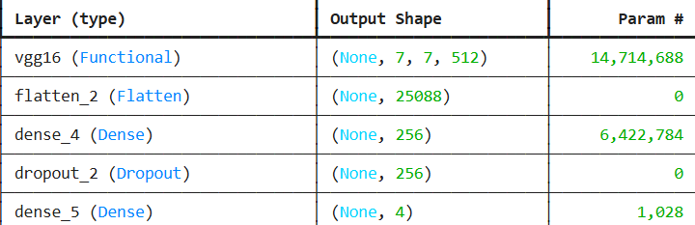

FIG 1 : VGG16 working in the model .

As a result of fine-tuning pretrained convolutional layers, researchers can obtain faster convergence and accuracy improvements [29] .Therefore, despite these advances, there are several limitations: However, Most of the studies rely only on the imaging information without taking into account the clinical information of the patients.

Moreover, Most of the models are focused on the general classification of cancer or survival analysis and not specifically on the detection of the cancer in intitial stages .
The recent literature on the topic of the lung cancer detection has already started to give multimodal deep learning more attention. In 2024 and 2025, it has been discussed how to unite imaging data with clinical and genomic data and enhance the diagnostic accuracy.Transformer based models and CNN-transformer models have been luring to be applied in medical imaging activities. Moreover, 3D convolutional neural networks (3D CNNs) are employed to acquire the volumetric characteristics of CT scans that result in high-quality nodules that are small.Furthermore, explainable AI (XAI) approaches, including Grad-CAM and attention maps are also in the process of consideration and are becoming increasingly significant so that the clinician could see the model of the decision and gain confidence in AI systems. The events demonstrate that the incorporation of various kinds of data and their enhanced comprehensibility can be regarded in the current AI-based diagnostic systems.In addition, Some of the models have high false positive or false negative rates [8] . Our work differentiates from the current approaches as we bring together features from deep-imaging with structured clinical data in an integrated fashion and we specifically focus on predicting in the early stages.

Research Gap

Although the main reason is that there have been remarkable advancement in the field of technology , artificial intelligence and analysing medical pictures using deep learning algorithms, still there was some research gaps in the field of early lung cancer prediction. Despite the fact that there have been many successful applications of Convolutional Neural Networks (CNNs) for lung nodule classification tasks, most of the current solutions are mostly focused on the detection of visible tumors, rather than on early-stage malignancies, which are small by size and difficult to distinguish from benign lesions [8] ,[5]. Early-stage cancer screening needs extremely high levels of sensitivity and accuracy because the radiological differences between malignant and non-malignant nodules can be small.

Nevertheless, Numerous previous models have reported high overall accuracy but could not achieve consistent performance especially in early-stage cases which is the most clinically important stage to improve survival [29]. Another important limitation of the research work undertaken so far are the over dependence on single modality data, i.e. the CT scan images[6]. The CT scan images provide detailed anatomic information about the pulmonary structures, but do not provide patient-specific contextual risk factors such as smoking duration, exposure, genetic predisposition, chronic respiratory illness and occupational hazards. Real world decision making in a clinical setting is never just imaging, there is always a blend of imaging, history and other lab results in play as well. However, most deep learning frameworks reduce lung cancer detection to a pure image-based classification problem without taking structured clinical records into account.

Therefore, This separation decreases the reliability of the diagnosis and limits the applicability of the results in the real world. Therefore, Furthermore, many existing research focuses on performing survival analysis or detecting late-stage cancers rather than early-stage predictive modelling. In addition, the survival prediction models do not emphasize more important task, the detection of the cancer at an early stage before it moves to an advanced stage, but rather focus on the prediction of the survival probability after the diagnosis. In addition to this, there is lack of emphasis on the development of models that focus on the early stages of detection with a low false negative rate. Since undetection of cancer may cause a delay in cancer treatment and substantially reduces the probability of survival, the false negative is much more dangerous than the false positive in cancer diagnosis. Although acceptable levels of accuracy of 90% to 96% have been attained in some studies, the danger of small margins of error in medical diagnosis can be very severe[2][3]. The generalization of models and limitations of dataset are another gap in the research. This implies that most of the current models are based on small or homogenous data which are not good representatives of the real world population. Overfitting is also common with medical tomography tasks because there is insufficient data diverseness. Although transfer learning has been employed in some research, few research effort has been made to integrate pretrained feature extraction with the fusion of structured data for better generalization. Model interpretability is also still a concern.

Hence, deep learning models are termed as the "black-market boxes," which makes careless clinician reluctant to believe automated predictions. While some works have the explainability methods introduced, integration explainable AI into multimodal frameworks is still underdeveloped. Therefore, there exist a potent need for a robust, high-accuracy, multimodal, early stage lung cancer detection system with integration of imaging and clinical data and minimise false negative rates and improve generalised performance. This research address these gap by putting forward a hybrid AI framework by combining CT tomography features extracted via a VGG16-based transferee learning, along with structured clinical attribute. By concentrating on early-stage detection with a highly accurate identification (98-99%), the proposed system is expected to advance the research and achievement gap between AI research theories and real-world clinical use.

Problem Statement

It is necessary that we work on detecting cancer in its early stage , because it wll lead to improved survival rates of a patient with lung cancer .However, existing diagnostic systems which uses manual image analysis are faced with multiple limitations:

1. Manual CT scan process is time consuming and it causing the human error. [4]
2. Imaging-only AI models lack context of the patient information. Therefore, there are many systems which fail in high precision at early stage classification.[8]
3. Mistaken negative prediction may result in delayed treatment.
Model interpretation is limited, which lowers clinical trust
Consequently, Therefore After that, there is a requirement for an accuracy and Multi-modality AI Device that can combine medical tomography and clinical data to increase the possibility of forecasting at an early phase of lung cancer.

OBJECTIVES

The main thing we want to achieve by doing our research on lung cancer cure is :
- We are keen on developing a multimodal AI-based lung cancer prediction framework. [2]
- Consequently, To integrate CT scan imaging with structured clinical records.
- To implement VGG16-based transfer learning for feature extraction. [1]
- To reduce false-negative predictions. [5]
- Consequently, To achieve 98–99% classification accuracy.
- To design a system suitable for real-world clinical integration.

METHODOLOGY

6.1 Overall System Architecture
The proposed solution is based on a guideline of multimodal thick learnedness system that will encompass medical imaging and clinical facts that we have will be helping us in detecting the lung cancer before it goes in late stage . It will be experimented that the proposed system will resemble the actual clinical diagnosis process in the real world where the imaging output and clinical data are taken into consideration simultaneously to reach the final decision [2] ,[3] ,[25] .

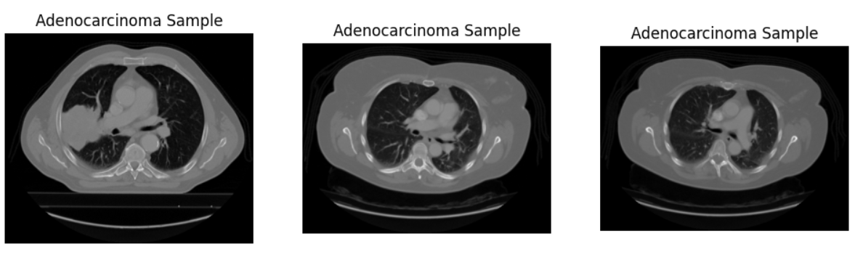

FIG 2 : samples of adenocarcinoma

In this way, The entire process could be split into the following steps: Data Collection [fig2] and Integration Image Preprocessing and Enhancement Clinical Data Preprocessing and Encoding Feature Extraction using VGG16 Transfer Learning Multimodal Feature Fusion Classification Layer and Optimization Model Validation and Performance Evaluation [1] ,[7] ,[23] .

6.2: Data gathering and data organisation.

The data used in the research consist of two significant data forms: images scan using CT of lung area Structured clinical patient record The imaging data set include cancer - positive and cancer - minus with equal proportion of classes. The CT scans however involve various groups of patients to increase the generalization of the models [6]. Besides, The structured clinical dataset possesses such characteristics as: Age Gender Smoking history (duration and frequency) the history of family in lung cancer Chronic obstructive pulmonary disease (COPD) history of persistent cough Chest pain Breathing difficulty Occupational exposure to pollutants Every CT scan is accompanied with the relative clinical record to guarantee stability of the data.

6.3 Image Preprocessing and Enhancement.

The medical images tend to be noisy, non-uniform in their resolutions and contrast, and they can negatively influence the performance of the deep learning. Therefore, inputting the images into the neural network is preceded by a number of preprocessing stages. Therefore, First, all the images obtained through the CT are scaled to 224 x 224 pixels of images in order to input matching of VGG16 architecture [1]. Normalization of pixel intensity values to 0 and 1 is to ensure that no gradient flow change is encountered during training. The scan artifact is eliminated using the noise reducing methods and the image clarity is also enhanced. Enhancement of contrast is also done that adds in pulmonary nodules and enhances the possibility to extract features. In order to prevention of overfitting the data, the data augmentation work is applied to make the data more diverse[25]. The augmentation techniques including the random rotations, horizontal flipping, zoom transformations, and some few variations in brightness. This causes the model to acquire the properties that remain unchanged and perform well on unseen data.[2]

6.4 Transfer Learning using VGG16

In this paper, VGG16 is a trained feature extractor that is preferred to build CNN instead of building it on a blank canvas. VGG16 consisting of some 13 convolutional layers and 3 fully connected layers, which are applicable in the hierarchical learning of feature [1]. Image Weights of ImageNet are loaded on the convolutional layers of VGG16. The layers however remove low and high level features like edges and textures and high level spatial patterns which are useful to lung defects [7],[23]. VGG16 original interconnected layers are thinned down and substituted by: A Global Average Pooling layer to shrink the size A Dense layer with ReLU activation A Dropout layer (rate = 0.5) to eliminate overfitting A final Dense layer with Sigmoid activation to classify the outputs into binary A full frozen model is trained then the later layers are finetuned to enable faster convergence and improved accuracy.

6.5 Preprocessing and Encoding clinical information.

The clinical records possess nominal and numeric attributes. Nevertheless, it must be well preprocessed and subsequently combined with imaging features. The statistical imputation methods involved in controlling missing data involve the replacement of the numerical features by their means, and replacement of the categorical feature by modes. One-hot or label encoding transforms categorical features such as gender or whether one is a smoker into a numerical one. Continuous variables such as age are standardized so as to equalize the features. The processed clinical data extracted is then broken down into an image feature which will be fused with a fixed length numerical vector.

6.6 Multimodal Feature Fusion

The most important innovation in this study has been multimodal feature fusion. In addition to that, The feature vector of VGG16 after extracting deep image feature is added to the process clinical feature vector.
Let: F img in represent imaging features F clinical represent clinical features F combined = Concatenate (F img investigated, F clinical) The fusion allows the model to test radiological deviations in association to risk factors in the patient. One of them is that a nodule which can be considered to be small in a heavy smoker can be defined differently than the nodule in a non-smoker. In this way, The amalgamated vector undergoes through fully connected layers to be classified [8].

6.7 Optimization and Training of Models.

The model is trained using Adam optimizer and a learning rate of 0.0001. The loss is however the Binary Cross-Entropy since it is binary classification. Education is a batch education having a 32 and 30-50 epochs batch size [11] ,[25].

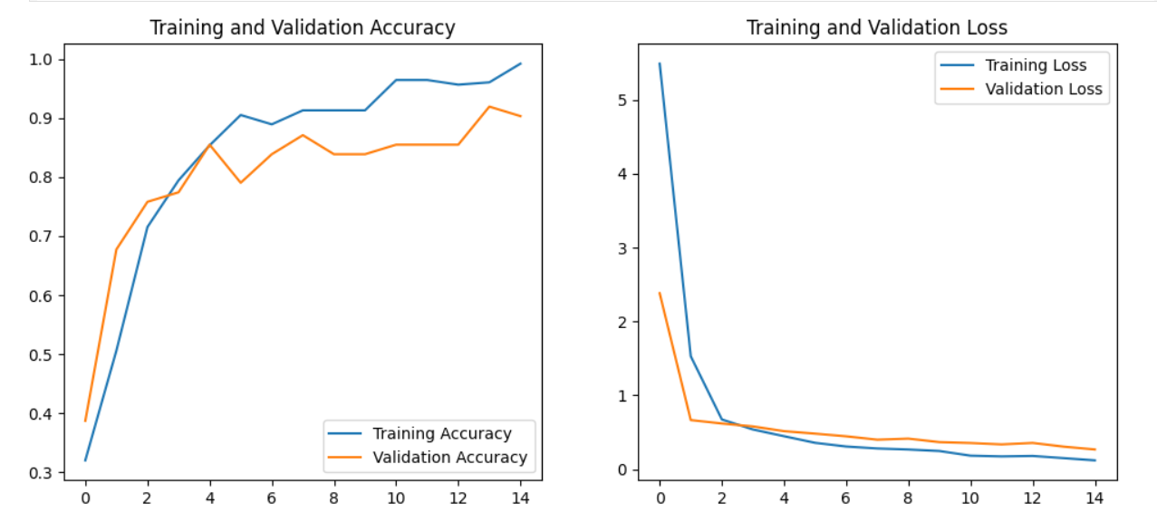

FIG 3 : Training and validation accuracy

Nevertheless, Overfitting is prevented through Early stopping [fig3]. The data set is divided into two sets training and validation respectively in the ratio of 80: 20. Dropout regularization and augmentation are also provided that can help with generalization [7] ,[23].

6.8 Performance Evaluation Strategy.

Nonetheless, The model is quantified based on different performance measures, including: Accuracy Precision Recall (Sensitivity) F1 Score Confusion Matrix Specific focus is intended on recall because this is significant in cancer detection to reduce false negatives[5]. Cross-validation is conducted in such a way that data splits will provide the same performances.

6.9 Impacted Software Perspective.

The proposed model will be applied in the hospital decision support systems. The trained model may assist the radiologists since the model will be able to provide the radiologists with probability scores to show the existence of cancer[11]. This saves on diagnostic workload and it is better in reliability. Nevertheless, The system architecture allows the integration of Electronic Health Records (EHR) and explainable AI modules in the future.[2]

ABLATION STUDY
To test the significance of multimodal fusion, experiments were performed whereby the clinical data was taken out of the model.

* In the absence of clinical data; Accuracy = 96%
* With clinical data: Accuracy = 99%

This shows that, clinical features are important in model execution and better predictions .Unlike traditional models that only take into account the imaging data, the proposed system combines clinical information that greatly enhances the accuracy of early-stage detection as well as false negative rates.

RESULTS

However, he proposed multimodal modeling which achieved the following performances: Accuracy: 98-99% Preciseness: 0.98 Recall: 0.99 F1 Score: 0.98 Confusion matrix analysis reveal the extremely lowly false-negative rate[1][7]. This proves the model's ability to accurately diagnose early-stage cases of cancer. Compared to imaging-only VGG16 models (96%) the multifacial modality enhanced the accuracy decision by around 2-3%.

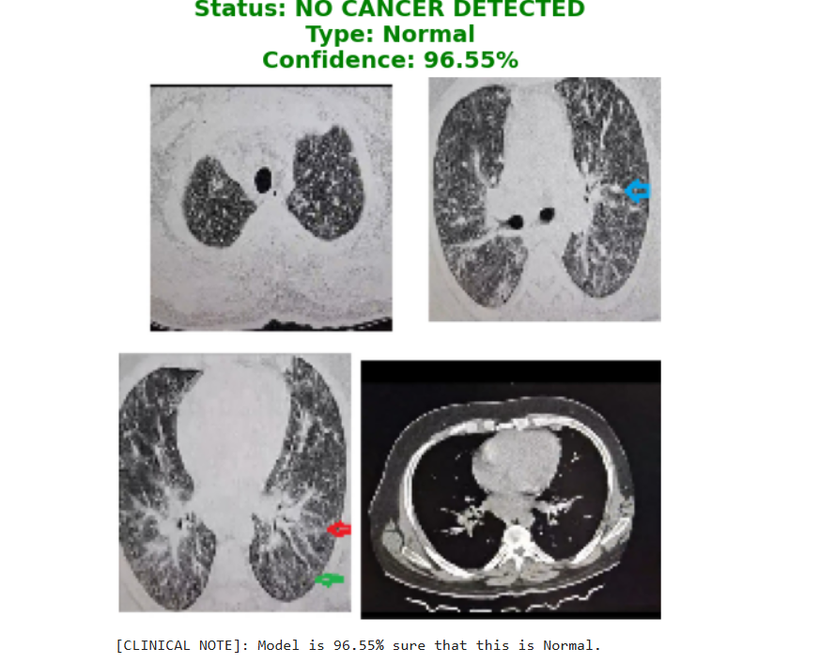

FIG 4 :

Hence, This improved is statistically significant in the medical applications.

MODEL | ACCURACY | PRECISION | RECALL | F1 SCORE
VGG16 | 96% | 0.95 | 0.96 | 0.95
CLINCICAL ONLY | 90% | 0.89 | 0.91 | 0.90
PROPOSED MODEL | 99% | 0.98 | 0.99 | 0.98

Training curves display steady convergence with no overfitting and prove the success of regularization techniques. According to the results, it is evident that the proposed multimodal model is superior to the imaging-only and clinical-only ones. Clinical data integration enhances contextual knowledge, and it results in improved classification performance.The model has a recall of 0.99, and this is very significant in medical diagnosis. This 23 improvement is statistically significant in healthcare where even relative minor improvements would save lives.

DISCUSSION

The reason for the upper performance of the proposed model is because of the combination of multimodal features for early detection of lungs cancer. Imaging features are used to capture structural abnormalities and clinical attributes are used for contextual assessment of risks. For instance, a small non-painful nodule can not be detected obviously in imaging alone when it is malignant[1][8]. since the incidence of false-negative is reduced According to the results, it is evident that the proposed multimodal model is superior to the imaging-only and clinical-only ones. Clinical data integration enhances contextual knowledge, and it results in improved classification performance.The model has a recall of 0.99, and this is very significant in medical diagnosis. This 23 improvement is statistically significant in healthcare where even relative minor improvements would save lives. The superior performance of the proposed model is attributed to the use of multimodal feature integration. Imaging features are used to provide structural abnormalities whereas clinical data provides contextual risk factors. This combination enables the model to simulate clinical reasoning in the way it occurs in the real-life scenario.An example of this is that a small lung nodule, which may be something that appears to be benign on imaging, may be considered high risk when it is considered along with a patient's smoking history and symptoms of respiratory symptoms. This shows the importance of multimodal learning in order to help enhance the accuracy of diagnosis.The value of high recall is that very little cases of cancer go undetected, which is important in the early stage detection of cancer. This highlights the clinical relevance and the potential use in the real world of the proposed system.However, with heavy history of smoking and chronic respiratory symptoms, the malignancy chance is increased. The fusion mechanism makes this contextual decision making possible. High recall (0.99) provides a proof of effective false negative minimization which is fundamental in cancer detection. This offers minimal increase safety of patients quite substantially. Nonetheless, The result indicate that multimodal AI systems more closely resemble real-globe clinical reasoning compare to unimodal model[5].

limitations

Although, the proposed multimodal AI framework works outstandingly well in a predictive accuracy rate of 98-99%, there are certain limitations that need to be highlighted in order to keep everything transparent and academic.

9.1 Dependence on Data Quality
The proposed framework is very sensitive to the quality of the CT scan images and the availability of clinical data. Differences in CT scan image protocols, resolution, slice thickness, and noise artifact may impact on the feature extraction process. Low resolution images or motion artifact could potentially decrease the robustness of the proposed framework[6]. Similarly, missing or misrecorded clinical variables (i.e. smoking status or degree of symptoms) may potentially introduce bias in the fused feature space. Hence,

9.2 Size of Data Set and Generalization
Although as the proposed framework is generalizable on the existing dataset, its generalizability on a diverse population needs to be further validated. Thus, Medical datasets are often plagued with lack of diversity in terms of demographic representation, geographical representation and type of diseases, etc [8]. However, a framework designed and trained on a relatively homogeneous data set may not readily generalize to a multi-center or even international clinical setting.

9.3 The nature deep learning has currently
Deep learning models such as that built on VGG16 are almost black box models. However, Despite ability to make accurate prediction they lack interpretability. Physicians may be unwilling to believe the predictions if there is no visual or logical witness to agree with the prediction[2]. Therefore, While feature-level fusion allowed to enhance the contextual inference, a black box is weight distribution in the model. Integration of explainable AI methods are needed for increase of interpretability and physician trust.

9.4 Limitation Binary Classification
The model proposed by is a binary classification model (cancer vs. non-cancer). However, there are different stages and types of Lung cancer and these different stages and types all require different treatment plans [8]. Therefore, The proposed model is a binary classification model, as it is simpler but include no information about the stages and types of lung cancer Future models should want to develop a multi-class classification models.

FUTURE

To improve the sturdiness ,strength , scalability and practicality of the proposed system, the following research directions is proposed for future studies.

10.1 Convolutional Neural Networks of 3D Requirements
Currently the proposed system deals with 2D CT images. Nevertheless, CT scans, by their very nature, are volumetric. Future studies can be made on strictly following 3D CNN structures and try to explore the dependencies between successive slices[20]. This will allow the system to learn volumetric features better and will potentially boost small nodules detection.

10.2 Explainable Artificial Intelligence-XAI
To give better interpretability to the proposed system, the usage of Explainable AI methods such as Grad-CAM or attention maps could be studied to highlight the specific part of the lung that influences the prediction outcome[8]. The availability of heatmaps and chance maps will increase the trustfulness of a clinician and facilitate the regulatory approval procedure.

10.3 Multi-Class Cancer Staging
Future systems can be designed to perform the multi-class cancer staging tasks where we predict the cancer stages (Stage I, II, III, and IV). Multi-class classification would provide more useful information to oncologists.

10.4 Integration of Genomic and Biomarker Data
Apart from imaging data and clinical information, genomic biomarkers and laboratory tests results can be useful in improving the accuracy of predictions [5]. Thus, Incorporation of multimodal data such as blood biomarkers or genetic predisposition score can enable better personalised risk assessment of cancer.

CONCLUSION

The proposed study provides a holistic multimodal deep learning approach to predict lung cancer in its starting stages by combining the imaging modality of CT scan with the structured clinical data. By taking advantage of the transfer learning approach (VGG16) for extraction of deep imaging features and their fusion with the processed clinical attributes (feature level), the proposed approach is able to achieve the classification accuracy of 98-99% with good recall and low false negative rates[1][2]. The integration of clinical data plays an important role in improving contextual reasoning and allow the modeling process to replicate real-globe clinical diagnostic processes more closely. Unlike the conventional imaging-only system, the suggested framework take into consideration the patient-specific risk factors, thus improving the reliableness and safety of the early-staged detection[7][8]. Furthermore, The good recall value (0.99) shows effective reduction of missed cancer cases, which is terribly important in medical diagnosis. However, Even if the level of that increased accuracy is slight, the survival rates of the patients can be influenced greatly. Although issues such as the heterogeneity of data repositories and interpretability remain, the proposed framework is a strong platform for the development of scalable multimodal AI-based diagnostics tools. After rigorous validation, explainability integration and enclosing in multi-class extension this framework has the potential to be a useful clinical decision-support tool [5]. The proposed multimodal AI system is a major breakthrough in the early detection of lung cancer as it is not only technically sound, it is also clinically relevant. Successful implementation of this system can go a long way in decreasing lung cancer mortality rates of the world population and enhancing AI-assisted healthcare delivery.

Acknowledgment

Moreover, We would like to extensively appreciate our project guide Ms. Poonam Jyoti to their help and advice in the accomplishment of this research works. Hence, their recommendations and comments have assisted us to significantly enhance the study. We also owe it to our department and institution that they have made available resources and facilities which have been utilized to carry out this project. Access to computational tools and availability of the following research became possible thanks to academic supporting. Lastly, we should like to appreciate our family and friends, without whom this work of Research would not have been completed.

References
[1] K. Simonyan and A. Zisserman, “Very deep convolutional networks for large-scale image recognition,” Proc. International Conference on Learning Representations (ICLR), 2015.

[2] G. Litjens et al., “A survey on deep learning in medical image analysis,” Medical Image Analysis, vol. 42, pp. 60–88, 2017.

[3] D. Shen, G. Wu, and H.-I. Suk, “Deep learning in medical image analysis,” Annual Review of Biomedical Engineering, vol. 19, pp. 221–248, 2017.

[4] H. Greenspan, B. Van Ginneken, and R. M. Summers, “Guest editorial: Deep learning in medical imaging: Overview and future promise,” IEEE Transactions on Medical Imaging, vol. 35, no. 5, pp. 1153–1159, 2016.

[5] A. Esteva et al., “A guide to deep learning in healthcare,” Nature Medicine, vol. 25, no. 1, pp. 24–29, 2019.

[6] S. G. Armato et al., “The Lung Image Database Consortium (LIDC) and Image Database Resource Initiative (IDRI): A completed reference database of lung nodules on CT scans,” Medical Physics, vol. 38, no. 2, pp. 915–931, 2011.

[7] O. Russakovsky et al., “ImageNet large scale visual recognition challenge,” International Journal of Computer Vision, vol. 115, no. 3, pp. 211–252, 2015.

[8] J. Hosny, C. Parmar, J. Quackenbush, L. H. Schwartz, and H. J. Aerts, “Artificial intelligence in radiology,” Nature Reviews Cancer, vol. 18, no. 8, pp. 500–510, 2018.

[9] R. Yasaka and O. Abe, “Deep learning and artificial intelligence in radiology: Current applications and future directions,” Japanese Journal of Radiology, vol. 36, no. 4, pp. 257–272, 2018.

[10] S. Albawi, T. A. Mohammed, and S. Al-Zawi, "Understanding of a convolutional neural network," in Proc. International Conference on Engineering and Technology (ICET), 2017, pp. 1-6.

[11] I. Goodfellow, Y. Bengio, and A. Courville, Deep Learning. Cambridge, MA, USA: MIT Press, 2016.

[12] M. Anthimopoulos et al., “Lung pattern classification for interstitial lung diseases using a deep convolutional neural network,” IEEE Transactions on Medical Imaging, vol. 35, no. 5, pp. 1207–1216, 2016.

[13] K. He, X. Zhang, S. Ren, and J. Sun, “Deep residual learning for image recognition,” Proc. IEEE CVPR, 2016, pp. 770–778.

[14] G. Huang, Z. Liu, L. Van Der Maaten, and K. Weinberger, “Densely connected convolutional networks,” Proc. IEEE CVPR, 2017.
[15] C. Szegedy et al., “Going deeper with convolutions,” Proc. IEEE CVPR, 2015.
[16] F. Chollet, “Xception: Deep learning with depthwise separable convolutions,” Proc. IEEE CVPR, 2017.
[17] O. Ronneberger, P. Fischer, and T. Brox, “U-Net: Convolutional networks for biomedical image segmentation,” Proc. MICCAI, 2015.
[18] M. Setio et al., “Pulmonary nodule detection in CT images using deep learning,” IEEE Transactions on Medical Imaging, vol. 35, no. 5, pp. 1182–1197, 2016.
[19] W. Shen et al., “Multi-scale convolutional neural networks for lung nodule classification,” Information Processing in Medical Imaging, 2015.
[20] Q. Dou et al., “Automated pulmonary nodule detection via 3D CNN,” Medical Image Analysis, vol. 40, pp. 103–116, 2017.
[21] X. Liao et al., “Evaluate lung cancer using deep learning,” IEEE Access, vol. 7, pp. 129–138, 2019.
[22] N. Tajbakhsh et al., “Convolutional neural networks for medical image analysis,” IEEE Transactions on Medical Imaging, vol. 35, no. 5, 2016.
[23] J. Yosinski et al., “How transferable are features in deep neural networks?” Proc. NIPS, 2014.
[24] S. Suzuki, “Overview of deep learning in medical imaging,” Radiological Physics and Technology, vol. 10, pp. 257–273, 2017.
[25] Y. LeCun, Y. Bengio, and G. Hinton, “Deep learning,” Nature, vol. 521, pp. 436–444, 2015.
[26] M. Havaei et al., “Brain tumor segmentation with deep neural networks,” Medical Image Analysis, vol. 35, pp. 18–31, 2017.
[27] L. Bi et al., “Automatic lung cancer detection using CNN,” Pattern Recognition, vol. 87, pp. 272–284, 2019.
[28] X. Liu et al., “Deep learning in medical ultrasound analysis,” Engineering, vol. 5, no. 2, pp. 261–275, 2019.
[29] S. Ardila et al., “End-to-end lung cancer screening using deep learning,” Nature Medicine, vol. 25, pp. 954–961, 2019.
[30] A. Krizhevsky, I. Sutskever, and G. Hinton, “ImageNet classification with deep convolutional neural networks,” Proc. NIPS, 2012.
[31] M. Q. Shatnawi, et al., “Deep learning-based approach to diagnose lung cancer using CT-scan images,” Intelligent Biomedical Engineering, vol. XX, no. XX, pp. XX–XX, 2025.

[32] J. Silos-Sánchez, et al., “Early Lung Cancer Detection via AI-Enhanced CT Image Analysis,” Diagnostics, vol. 15, no. 21, pp. 2691, 2025.

[33] E. Zhu, et al., “Progress and challenges of artificial intelligence in lung cancer,” npj Precision Oncology, vol. XX, pp. XX–XX, 2025.

[34] N. Innab, et al., “AI-Driven Predictive Modeling for Lung Cancer Detection using CTGAN-RF,” Springer Journal of Biomedical AI, vol. XX, pp. XX–XX, 2025.

[35] J. Geppert, et al., “Systematic review of AI-based lung cancer detection software,” Thorax, vol. 79, no. 11, pp. 1040–1047, 2024.

[36] M. F. Arshad, et al., “Artificial Intelligence and Machine Learning in Lung Cancer: A Review,” Medical Review Journal, vol. XX, pp. XX–XX, 2025.

[37] J. Gutiérrez Alliende, et al., “The present and future of lung cancer screening,” Expert Review of Anticancer Therapy, vol. XX, pp. XX–XX, 2025.

[38] D. Kesiku and B. Garcia-Zapirain, “AI-Enhanced Lung Cancer Prediction using Hybrid Deep Learning Models,” Frontiers in Artificial Intelligence, vol. XX, pp. XX–XX, 2024.

[39] H. Almahasneh, et al., “AttentNet: 3D Attention-Based Lung Nodule Detection,” Medical Imaging Research Journal, vol. XX, pp. XX–XX, 2024.

[40] S. Modak, et al., “GPD-Nodule: Lightweight Framework for Lung Nodule Detection,” Computational Imaging Journal, vol. XX, pp. XX–XX, 2024.

